RStdio Project : Network Analysis

1st step: Network Analysis

2nd step: Network measures

3rd step: Read data

4th step: Create Network

5th step: Histogram of node degree

6th step: Network diagram

7th step: Community detection

1st step: Network Analysis

First we have made a network. Four network are connected.

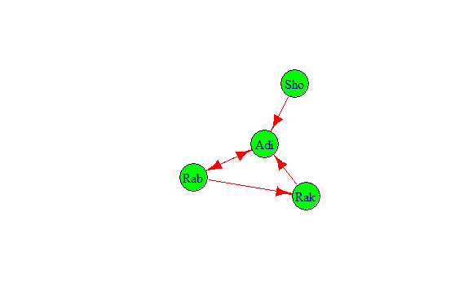

We have found Adi is connected each other. Aid send mail to Rab and Rab send mail to Aib.Rak send mail to Adi but Adi don’t send to Rak. Sho send mail to Adi but Adi don’t send.

2nd Step: Network Measure

We have measured how many mail are send to each other. How many email are in and out. We have measured diameter,density,reciprocity,closeness,betweenness,edge-betweeness.

3rd Step: Read data

By this code : data <- read.csv(file.choose(),header = T) y <- data.frame(data$first,data$second)

We read that the file have 290 objects and 4 variables.

5th Step: Histogram of node degree

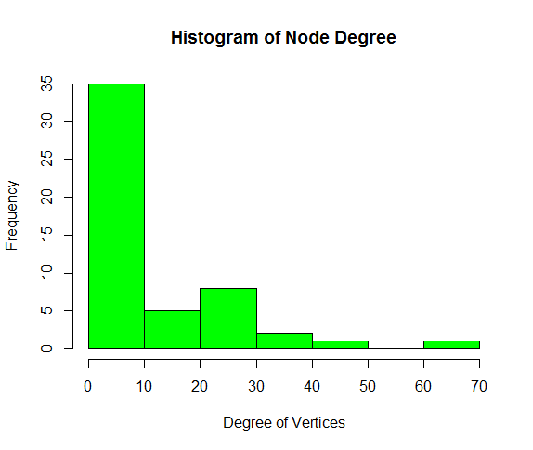

From Histogram chart there are 35 nodes between 0 to 10. 50 to 60 has 0 nodes but high connections.

6th Step: Network diagram

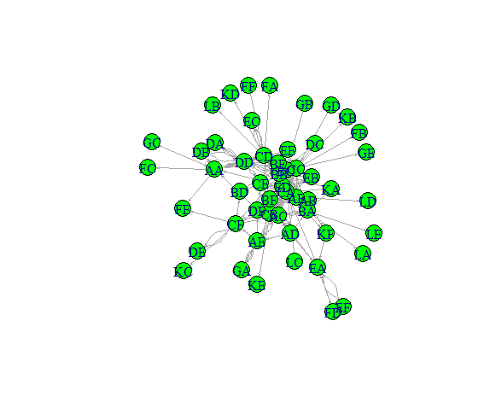

From there we have done the vertex color and size, and edge arrow size.

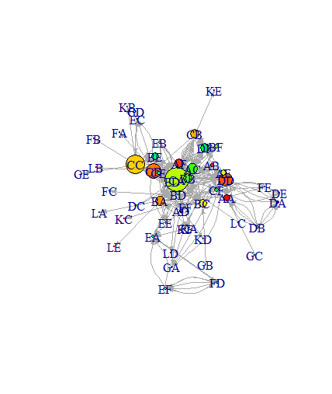

We can see the nodes are bigger and smaller based on the degree.

7th Step: Community detection

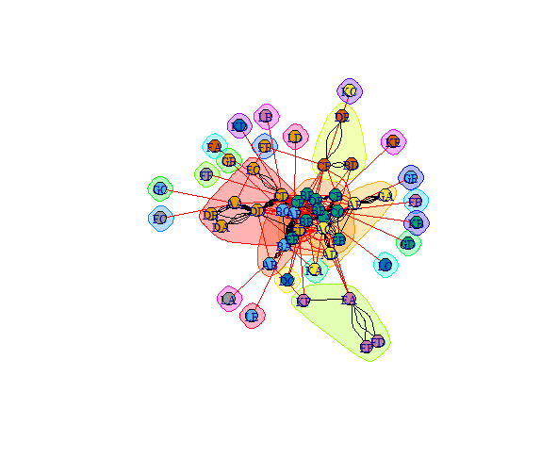

From this fig we understood that how many groups are available, how makes the group and who many people are in a group.